**DETECTION OF DIABETIC RETINOPATHY USING**

**IMAGE PROCESSING**

Mini Project report submitted in partial fulfilment of the requirement for the award of the degree

**Bachelor of Engineering**

**in**

**Biomedical Engineering**

**By**

**K. LAHARI (100519731013)**



**DEPARTMENT OF BIOMEDICAL ENGINEERING**

**UNIVERSITY COLLEGE OF ENGINEERING (A)**

**OSMANIA UNIVERSITY, HYDERABAD-07**

**(2019-23)**

**DETECTION OF DIABETIC RETINOPATHY USING**

**IMAGE PROCESSING**

Mini Project report submitted in partial fulfilment of the requirement for the award of the degree

**Bachelor of Engineering**

**in**

**Biomedical Engineering**

**By**

1. **MANASWINI (100519731003)**



**DEPARTMENT OF BIOMEDICAL ENGINEERING**

**UNIVERSITY COLLEGE OF ENGINEERING (A)**

**OSMANIA UNIVERSITY, HYDERABAD-07**

**(2019-23)**

**(2019-23)**

**DEPARTMENT OF BIOMEDICAL ENGINEERING**

**UNIVERSITY COLLEGE OF ENGINEERING**

**OSMANIA UNIVERSITY**



**CERTIFICATE**

This is to certify that the mini project report entitled **“DETECTION OF DIABETIC RETINOPATHY USING IMAGE PROCESSING”** is being submitted by **Sri/Ms K. Lahari** bearing **Roll No.100519731013** in partial fulfilment of the requirement for the award of the degree **Bachelor of Engineering** **in** **Biomedical Engineering**, University College of Engineering(A), Osmania University, Hyderabad is a record of bonafide work carried out by him, under my guidance and supervision. The results embodied in this project report have not been submitted to any other university or institute for the award of any degree or diploma.

Date:

SIGNATURE OF HEAD SIGNATURE OF GUIDE

DR. D. SUMAN Mr. M. SRINIVAS

Associate Professor Assistant Professor

Dept. of BME, UCE, OU Dept. of BME, UCE, OU

**(2019-23)**

**DEPARTMENT OF BIOMEDICAL ENGINEERING**

**UNIVERSITY COLLEGE OF ENGINEERING**

**OSMANIA UNIVERSITY**



**CERTIFICATE**

This is to certify that the mini project report entitled **“DETECTION OF DIABETIC RETINOPATHY USING IMAGE PROCESSING”** is being submitted by **Sri/Ms A. Manaswini** bearing **Roll No.100519731003** in partial fulfilment of the requirement for the award of the degree **Bachelor of Engineering** **in** **Biomedical Engineering**, University College of Engineering(A), Osmania University, Hyderabad is a record of bonafide work carried out by him, under my guidance and supervision. The results embodied in this project report have not been submitted to any other university or institute for the award of any degree or diploma.

Date:

SIGNATURE OF HEAD SIGNATURE OF GUIDE

DR.D. SUMAN Mr. M. SRINIVAS

Associate Professor Associate Professor

Dept. of BME, UCE, OU Dept. of BME, UCE, OU

**DECLARATION**

I hereby declare that the work reported in this report, entitled “DETECTION OF DIABETIC RETINOPATHY USING IMAGE PROCESSING” is a record of work done by me under the guidance of MR.M. SRINIVAS. Assistant Professor, Department of Biomedical Engineering, UCE(A). No Part of this report is copied from books/journals and wherever the portion has been taken the same has been duly referred in the text. The reports are based on the project work done entirely by me and not copied from any other source.

**K. LAHARI (100519731013)**

**A. MANASWINI (100519731003)**

**ACKNOWLEDGEMENT**

**Abstract**

Image segmentation is the process of partitioning a digital image into multiple segments (set of pixels also known as image objects). The goal of segmentation is to simplify and/or change the representation of an image into something that is more meaningful and easier to analyse. Retinal imaging is a common clinical procedure used to record a visualization of the retina. Segmentation of blood vessels in retinal images is used for the early diagnosis of retinal diseases such as hypertension, diabetes and glaucoma. The segmentation of blood vessels is an important pre-processing step for the early detection of retinal diseases. Retinal vasculature extraction helps in diagnosing the early detection of diabetic retinopathy to prevent blindness. The morphology of blood vessels in retinal fundus images is an important indicator of diseases like glaucoma, hypertension and diabetic retinopathy. Diabetic retinopathy (DR) is an eye disease which occurs due to damage of retina as a result of long illness of diabetic mellitus. A variety of methods have been proposed for detection and diagnosis of DR. Diabetic retinopathy detection contains three steps -pre-processing of colour fundus images, diagnostic feature extraction and classification of DR. So by using several image algorithms we find the thickness of the blood vessels which determine the severity of diabetes a person may have.

**INDEX**

**Acknowledgement………………………………………………… i**

**Abstract……………………………………………………………. ii**

**Index………………………………………………………………. iii**

**List of figures……………………………………………………... iv**

**List of Tables……………………………………………………... v**

**Table of content**

**Chapter 1 Introduction**

* 1. Introduction
  2. Overview
  3. Project Objective

**Chapter 2. Literature review**

2.1 Introduction

**Chapter 3. Image processing**

3.1 Introduction

3.2Digital Image:

3.3 Applications of image processing

3.4 Block diagram of image processing

**Chapter 4. Methodology**

4.1 Introduction

4.2 Pre-processing of retinal images

4.2.1 Low Pass Filters

4.2.2 Homomorphic Filtering

4.2.3 Histogram Equalization

4.3 Segmentation of Retinal Images

4.3.1. Segmentation methods

**Chapter 5. Image Segmentation Technologies and Blood Vessel Extraction**

5.1 Introduction

5.1.1 Threshold Based Segmentation

5.1.2 Edge Based Segmentation

5.1.3 Clustering Techniques

5.2 Thresholding

5.3 Histograms

5.4 Blood Vessel Extraction

5.5 Optic Disc Detection

**CHAPTER 1**

1. **INTRODUCTION**

**1.1 Introduction:**

People with diabetes can have an eye disease called diabetic retinopathy. This is when high blood sugar levels cause damage to blood vessels in the [retina](https://www.aao.org/eye-health/anatomy/retina-list). These blood vessels can swell and leak. Or they can close, stopping blood from passing through. Sometimes abnormal new blood vessels grow on the retina. All of these changes can steal your vision.

You can have diabetic retinopathy and not know it. This is because it often has no symptoms in its early stages. As diabetic retinopathy gets worse, you will notice symptoms such as:

* seeing an increasing number of floaters,
* having blurry vision,
* having vision that changes sometimes from blurry to clear,
* seeing [blank or dark areas in your field of vision](https://www.aao.org/eye-health/symptoms/dark-spots),
* having [poor night vision](https://www.aao.org/eye-health/symptoms/night-vision-problem), and
* noticing colours appear faded or washed out
* losing vision.

Diabetic retinopathy symptoms usually affect both eyes.

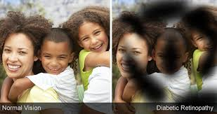

There are two types of diabetic retinopathy:

* **Early diabetic retinopathy.** In this more common form — called non proliferative diabetic retinopathy (NPDR) — new blood vessels aren't growing (proliferating).

When you have NPDR, the walls of the blood vessels in your retina weaken. Tiny bulges protrude from the walls of the smaller vessels, sometimes leaking fluid and blood into the retina. Larger retinal vessels can begin to dilate and become irregular in diameter as well. NPDR can progress from mild to severe as more blood vessels become blocked.

Sometimes retinal blood vessel damage leads to a buildup of fluid (edema) in the center portion (macula) of the retina. If macular edema decreases vision, treatment is required to prevent permanent vision loss.

* **Advanced diabetic retinopathy.** Diabetic retinopathy can progress to this more severe type, known as proliferative diabetic retinopathy. In this type, damaged blood vessels close off, causing the growth of new, abnormal blood vessels in the retina. These new blood vessels are fragile and can leak into the clear, jellylike substance that fills the center of your eye (vitreous).

Eventually, scar tissue from the growth of new blood vessels can cause the retina to detach from the back of your eye. If the new blood vessels interfere with the normal flow of fluid out of the eye, pressure can build in the eyeball. This buildup can damage the nerve that carries images from your eye to your brain (optic nerve), resulting in glaucoma.

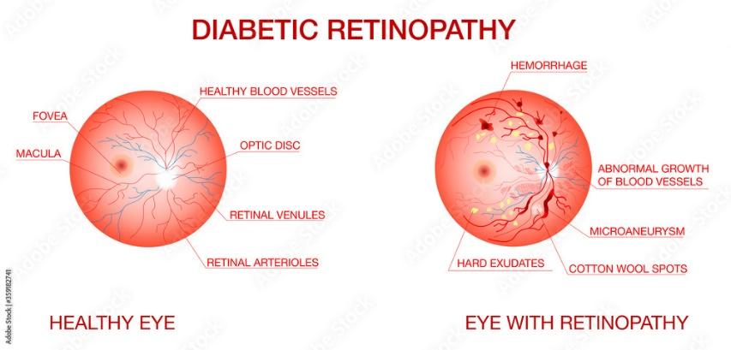

**Microaneurysms** (MA) is the earliest sign of DR that appears as small red round dots on the retina due to the weakness of the vessel's walls. The size is less than 125 μm and there are sharp margins. Michael et al. Classified MA into six types, as shown in Fig.2. The types of MA were seen with AOSLO reflectance and conventional [fluorescein](https://www.sciencedirect.com/topics/medicine-and-dentistry/fluorescein) imaging.

**Hemorrhages**(HM) appear as larger spots on the retina, where its size is greater than 125 μm with an irregular margin. There are two types of HM, which are flame (superficial HM) and blot (deeper HM), as shown in Fig.2.

**Hard exudates** appear as bright-yellow spots on the retina caused by leakage of plasma. They have sharp margins and can be found in the retina's outer layers.

**Soft exudates** (also called cotton wool) appear as white spots on the retina caused by the swelling of the nerve fiber. The shape is oval or round.

Red lesions are MA and HM, while bright lesions are soft and hard exudates (EX).

**1.2 Project objective:**

In the healthcare field, the treatment of diseases is more effective when detected at an early stage. Diabetes is a disease that increases the amount of glucose in the blood caused by a lack of insulin. The rapid development and proliferation of medical imaging technologies is revolutionizing medicine. Image Segmentation, which aims at automated extraction of object boundary features, plays a fundamental role in understanding image content for searching and mining in medical image archives. Manual segmentation is often impractical for large scalar longitudinal projects. The development of robust image segmentation methods is necessary to overcome the limitations of manual segmentation.

The use of computers in facilitating their processing and analysis has become necessary. In particular, computer algorithms for the delineation of anatomical structures and other regions of interest are a key component in assisting and automating specific radiological tasks. These algorithms, called Image segmentation algorithms, play a vital role in numerous biomedical imaging applications such as the quantification of tissue volumes, diagnosis, localization of pathology, study of anatomical structure, treatment planning, partial volume correction of functional imaging data, and computer integrated surgery.

The automated methods and procedures described in this work are motivated by the need to segment retinal images. The implementation of these tools, however, is suitable for more general segmentation problems that could include any imaging modalities or segmentation targets. Manual segmentation of the retinal blood vessels is arduous and time-consuming. Thus, automated segmentation is valuable as it decreases the time and effort required. Mostly, the algorithms for retinal blood vessel segmentation concentrate on automatic detection related to diabetic retinopathy, which is found to be the major cause of blindness in recent days.

A single image, but intensity information by itself is often not enough for an algorithm to give 3 satisfactory differentiation of target structure from high folded and inter-connected neighbours.

**1.3 Overview:**

To develop computational methods and algorithms to analyse and quantify biomedical data. The increasing number of images and the desire to reduce the human subjectivity, encourage the development and improvement of image processing and analysis algorithms. One of the difficulties in image capture of the ocular fundus is image quality, which is affected by factors, such as medial opacities, defocus or presence of artifact. Micro aneurysms (MAs) are the earliest clinical sign of Diabetic Retinopathy. MA detection at early stage can help to reduce the blindness. Our Project work is automatic detection for diabetic retinopathy using non-dilated retinal images at early stages. Our project proposes an automated system to identify diabetic affected eye among the several input retinal images. This is carried out in three stages namely Pre-Processing, Segmentation and Disease Abnormalities Detection. The Proposed method is evaluated using performance metrics.

**CHAPTER 2**

**2.LITERATURE REVIEW**

**2.1 Introduction:**

In the paper “AUTOMATED DIABETIC RETINOPATHY DETECTION AND CLASSIFICATION SYSTEM” the DR detection was performed by utilizing the characteristics of the DR features, such as intensity value, shape and size. The DR features that need to be detected are new vessels, Hemorrhages and exudates. The stages used in the proposed detection algorithm are image pre-processing, blood vessels and hemorrhages detection, optic disc removal and exudates detection. Image pre-processing was performed with the aim to decrease noises and to improve image contrast. The first step in the pre-processing is to extract image’s green component to be used in the following process. The reason of using green component is due to the highest contrast between blood vessels, optic disc, exudates and the background compared to the red and blue components. In addition, the red lesions(blood vessels and hemorrhages) appear dark and for the white lesions (exudates and optic disc), the features appear bright in the green plane image. Then, the second step is to perform noise reduction using median filter. Median filter is a nonlinear filter that is widely used for smoothing the image as it preserves edges while removing noise under certain condition [6]. In this work, the median filter was applied on the green channel image with 5x5 kernel.

Imed(x,y)=median{IG(s,t)}

where Imed represents median filtered image, W represents a neighbourhood centered around location (x,y) in the image and IG represents the green plane image. After noise reduction, the next step is to invert the image so that the colour of the blood vessels and hemorrhages is clearly seen. Then, the image contrast was improved using Contrast Limited Adaptive Histogram Equalization (CLAHE). This is in order to highlight the DR features.

INR = ICL – IBK

Itophat = INR ׺͙͑INR ஈ SE)

Iclose = (Itophat ْSE) Ĭ SE

Exudates are bright features that appear in different sizes and shapes. In this work, exudates were detected using morphological closing operation on green plane image, IG where the disc SE in the closing operation helps to eliminate the vessels.

The detection of blood vessels and hemorrhages are very crucial in the identification of DR stages. Based on our observation, the colour of hemorrhages is almost the same as blood vessels. Therefore, due to this reason, vessels and hemorrhages were detected together. The detection of vessels and hemorrhages was performed by filtering the features using a 5x5 median filter, with the reason of creating the background, IBK that is darker in intensity than the DR features. The background was used to produce a normalized image, INR, which was obtained by subtracting IBK from the enhanced image, ICL.

**CHAPTER 3**

**3.IMAGE PROCESSING**

**3.1 Introduction:**

Modern digital technology has made it possible to manipulate multi-dimensional signals with systems that range from simple digital circuits to advanced parallel computers. The goal of this manipulation can be divided into three categories:

• Image Processing image in → image out

• Image Analysis image in → measurements out

• Image Understanding image in → high-level description out.

We will focus on the fundamental concepts of image processing. Beginning with certain basic definitions. An image defined in the “real world” is considered to be a function of two real variables, for example, a(x,y) with a as the amplitude (e.g. brightness) of the image at the real coordinate position (x,y). An image may be considered to contain sub-images sometimes referred to as regions– of–interest, ROIs, or simply regions.

This concept reflects the fact that images frequently contain collections of objects each of which can be the basis for a region. In a sophisticated image processing system it should be possible to apply specific image processing operations to selected regions. Thus one part of an image (region) might be processed to suppress motion blur while another part might be processed to improve colour rendition. The amplitudes of a given image will almost always be either real numbers or integer numbers. The latter is usually a result of a quantization process that converts a continuous range (say, between 0 and 100%) to a discrete number of levels.

In certain image-forming processes, however, the signal may involve photon counting which implies that the amplitude would be inherently quantized. In other image forming procedures, such as magnetic resonance imaging, the direct physical measurement yields a complex number in the form of a real magnitude and a real phase.

**3.2 Digital Image:**

A digital image a [m, n] described in a 2D discrete space is derived from an analog image a(x,y) in a 2D continuous space through a sampling process that is frequently referred to as digitization. Looking forward to some basic definitions associated with the digital image. If a 2D continuous image a (x, y) is divided into N rows and M columns. The intersection of a row and a column is termed a pixel. The value assigned to the integer coordinates [m,n] with {m=0,1,2,…,M–1} and {n=0,1,2,…,N–1} is a[m,n]. In fact, in most cases a(x,y) – which we might consider to be the physical signal that impinges on the face of a 2D sensor – is actually a function of many variables including depth (z), color (λ), and time (t). The process of representing the amplitude of the 2D signal at a given coordinate as an integer value with L different gray levels is usually referred to as amplitude quantization or simply quantization.

**3.3 APPLICATIONS OF IMAGE PROCESSING:**

Applications of Image Processing - Visual information is the most important type of information perceived, processed and interpreted by the human brain. One third of the cortical area of the human brain is dedicated to visual information processing. Digital Image Processing, as a computer-based technology, carries out automatic processing, manipulation and interpretation of such visual information, and it plays an increasingly important role in many aspects of our daily life, as well as in a wide variety of disciplines and fields in science and technology, with applications such as television, photography, robotics, remote sensing, medical diagnosis and industrial inspection.

**3.4 BLOCK DIAGRAM OF IMAGE PROCESSING:**

Fundamental steps in digital image processing are shown in Fig. Image acquisition digitizes the image captured by camera. Image enhancement is the process of manipulating an image so that the results are more suitable for specific applications. Image restoration improves an appearance of an image, which tends to probabilities model of image degradation Morphological processes are the tools of extracting image components that are useful in the description and presentation of an image. Image segmentation is the most difficult ask in digital image processing which separates objects from the background. Representation makes the decision whether to represent data as boundary or as a complete region. Recognition is the process that assigns label to an object based on information provided by its descriptor.

Image Enhancement

Image Aquaisition

Input image

Image Segmentation

Image Rotation

Morphological processing

Representation and Description

Output Image

Object recognition

**CHAPTER 4**

**4. METHODOLOGY**

**4.1 INTRODUCTION:**

The proposed method is a fast and robust one to extract exudates in colour eye fundus image which is based on mathematical morphology where Blood vessels extraction is carried out which is followed by extraction of the hard exudates and optic disc and finally detection of the optic disc which is used for distinguishing it from exudates.

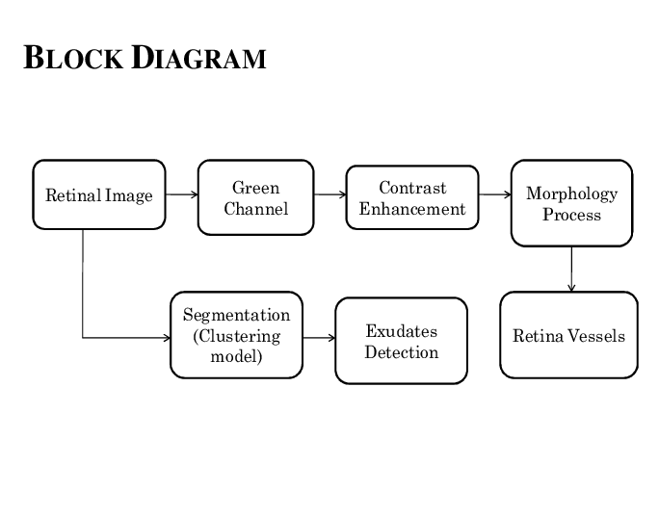

**4.2 PRE-PROCESSING OF RETINAL IMAGES:**

In detecting abnormalities associated with fundus image, the images have to be Pre-Processed in order to correct the problems of uneven illumination problem, nonsufficient contrast between exudates and image background pixels and presence of noise in the input fundus image. Pre-processing is an essential step in retinal image analysis which attenuates image variation by normalizing the original image with a reference model.

**4.2.1 Low Pass Filters:**

A low-pass filter is used to smooth an image. This reduces the effects of noise by cancelling out rapid variations from pixel to pixel. Noise appears as random spots in the image which usually are very different in value from their neighboring pixels. Light from the object being imaged very rarely changes in such a rapid manner; rather the brightness changes more gradually across 16 many pixels.

**4.2.2 Homomorphic Filtering:**

One of the popular methods used to enhance or restore the degraded images by uneven illumination is by using homomorphic filtering. This technique uses illumination-reflectance model in its operation. This model consider the image is been characterized by two primary components. The second component is the reflectance component of the objects on the scene r(x,y).

f(x,y) = i(x, y)r(x, y).......................................................................................... (1)

In this model, the intensity of i(x,y) changes slower than r(x,y)

In general, homomorphic filtering can be implemented using five stages, as stated as follows: **STAGE 1:** Take a natural logarithm of both sides to decouple i(x,y) and r(x,y) components

z(x, y) = ln i(x, y) + ln r(x, y)........................................................................... (2)

**STAGE2:** Use the Fourier transform to transform the image into frequency domain

: ℑ{z(x,y)} = ℑ{ln i(x,y)} + ℑ{ln r(x,y)} ......................................................... (3)

**STAGE3**: High pass the Z(u,v) by means of a filter function H(u,v) in frequency domain, and get a filtered version S(u,v) as the following:

S(u,v) H(u,v) Z(u,v) H(u,v) F(u,v) H(u,v) F(u,v)i r = = +................... (4)

**STAGE4:** Take an inverse Fourier transform to get the filtered image in the spatial domain: s(x,y)1{ S(u,v)} 1{ H(u,v) F(u,v) H(u,v) F(u,v)} i r= ℑ− = ℑ − + ...... (5)

**STAGE5:** The filtered enhanced image g(x,y) can be obtained by using the following equations: g(x,y)=exp{s(x,y)}....................................................................................... (6)

The drawbacks of this method is, as for all filtering scheme, that often, and especially in pathological images, low frequencies are associated with pathological signal of interest, which will be filtered out using these algorithms.

**4.2.3 Histogram Equalization:**

Histogram equalization is a technique for adjusting image intensities to enhance contrast. To transform the grey levels of the image so that the histogram of the resulting image is equalized to become a constant:

The purposes:

• To equally use all available grey levels

• For further histogram specification.

**4.3 SEGMENTATION OF RETINAL IMAGES:**

**4.3.1 Segmentation Methods**

With so many algorithms having been developed, classification of various techniques for image segmentation becomes an essential task.

Segmentation algorithms have been divided into three groups:

1. Thresholding or clustering (the latter is the multi-dimensional extension of the former)

2. Edge detection

3. Region extraction

Segmentation Modules It is based on mathematical morphology and has three modules:

(a) Blood Vessels extraction

(b) Extraction of the hard exudates and optic disc

(c) Detection of the optic disc, which is used for distinguishing it from exudates.

**CHAPTER 5**

**5. IMAGE SEGMENTATION TECHNOLOGIES AND BLOOD VESSEL EXTRACTION**

**5.1 Introduction:**

Segmentation is the process of dividing images into constituent sub regions with similar properties such as grey, colour, texture, brightness, and contrast.

The following categories are used:

**5.1.1 Threshold Based Segmentation:**

Histogram thresholding and slicing techniques are used to segment the image. They may be applied directly to an image, but can also be combined with pre- and post-processing techniques.

**5.1.2 Edge Based Segmentation:**

With this technique, detected edges in an image are assumed to represent object boundaries, and used to identify these objects.

**5.1.3 Clustering Techniques:**

Although clustering is sometimes used as a synonym for (agglomerative) segmentation techniques, we use it here to denote techniques that are primarily used in exploratory data analysis of high-dimensional measurement patterns.

In this context, clustering methods attempt to group together patterns that are similar in some sense. This goal is very similar to what we are attempting to do when we segment an image, and indeed some clustering techniques can readily be applied for image segmentation.

**5.2 THRESHOLDING:**

1. An initial threshold (T) is chosen; this can be done randomly or according to any other method desired.

2. The image is segmented into object and background pixels as described above, creating two sets: a. G1= {f(m,n):f(m,n)>T} (object pixels)

b. G2= {f(m, n):f(m,n)≤T} (background pixels) (note, f(m,n) is the value of the pixel

3. The average of each set is computed. a.m1= average value of G1 b.m2= average value of G2

4. A new threshold is created that is the average of m1 ,m2 is T = (m1 + m2)/2

5. Go back to step two, now using the new threshold computed in step four, keep repeating until the new threshold matches the one before it (i.e. until convergence has been reached) 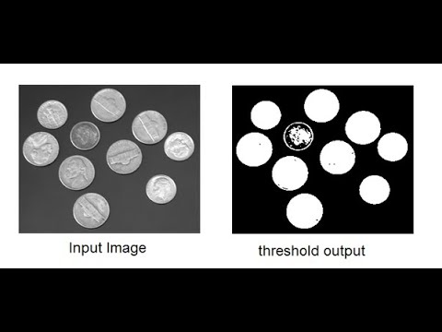 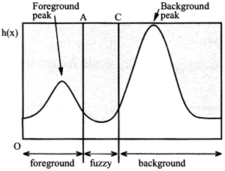

**5.3 Histograms:**

Histogram is constructed by splitting the range of the data into equal-sized bins (called classes). Then for each bin, the numbers of points from the data set that fall into each bin are counted.

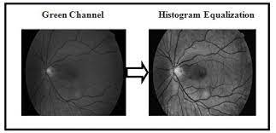

**5.4 Blood Vessel Extraction:**

The extraction and measurement of blood vessels can be used to quantify the severity of disease, as part of the process of automated diagnosis of disease.

**Step 1:** Read Input colour image.

**Step2**: Convert it into Grey image.

**Step 3:** Apply the threshold.

**Step 4:** By using kirsch's templates blood vessels are extracted.

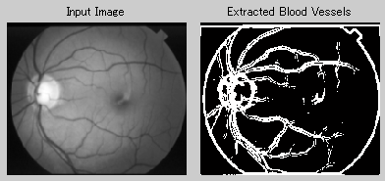

**5.5 Hard Exudates Extraction:**

Automated early detection of the presence of exudates can assist ophthalmologists to prevent the spread of the disease more efficiently. Hence, detection of exudates is an important diagnostic task.

**Step 1:** Read Input colour image

**Step 2:** Green component of input image is extracted.

**Step 3:** Morphological Bottom hat operation is performed on the green component of the image.

**Step 4:** Morphological Top hat operation is performed on the green component of the image.

**Step 5:** Subtract resultant image from step 4 with step 3.

**Step 6:** Optic disc elimination and hard exudates detection.

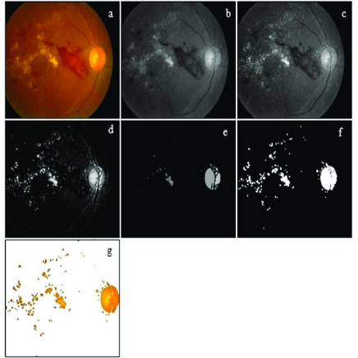

**5.5 Optic Disc Detection:**

The Optic Disk Detection is an important anatomical feature in retinal images, and its detection is vital for retinal image analysis.

**Step 1:** Read Input colour image.

**Step 2:** Extract Green channel from input image.

**Step 3:** Apply Otsu method to obtain fundus region.

**Step 4:** Perform morphological closing operation to the obtained image.

**Step 5:** Morphological opening is carried out to the above image.

**Step 6:** Subtract the above image from green channel image.

**Step 7:** Top hat and threshold the image obtained from above step.

